**Practical No.04**

* **Create and simulate a simple Ad-hoc network**

1. **Add two routers WRT300N**

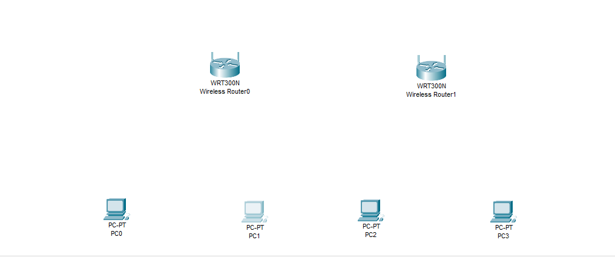

1. **Add two wireless pc to both routers**



1. **Wireless Router0 change the name (CS_router)**

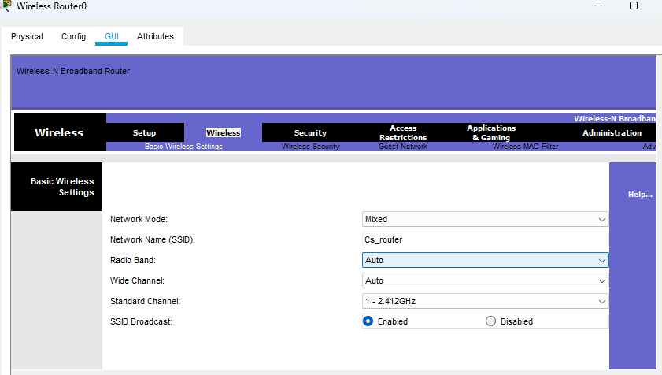

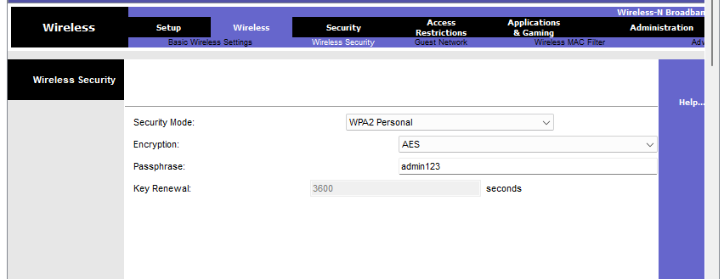

1. **Change the Remote management which is enable**

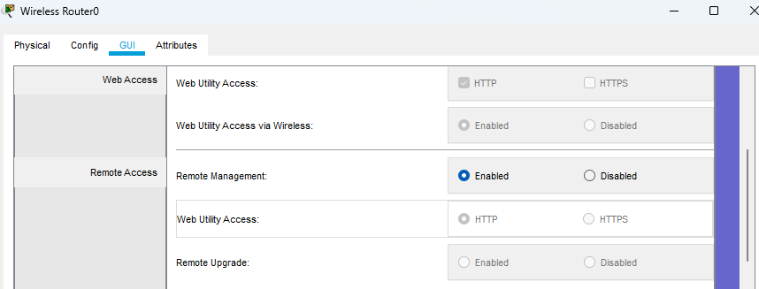

1. **Wireless Router0 change the name (IT_router)**

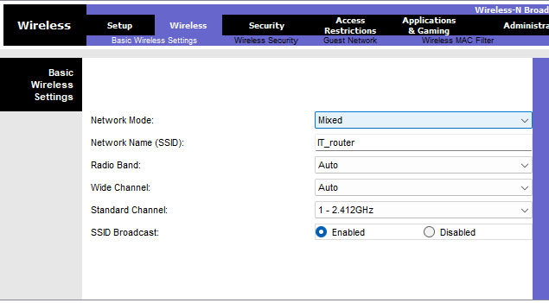

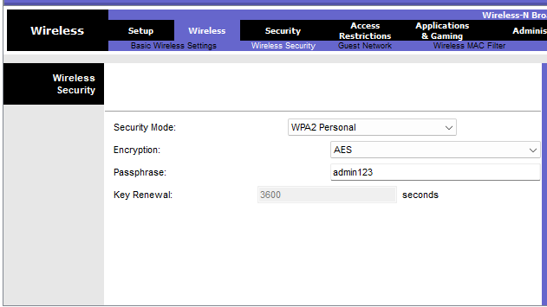

1. **Change the Remote management which is enable**



1. **Make each pc wireless connection for Router0**

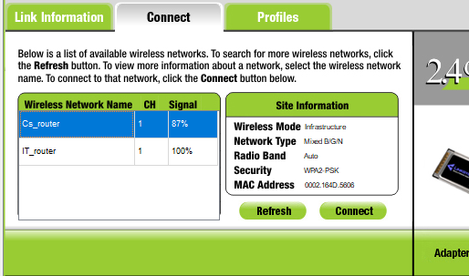

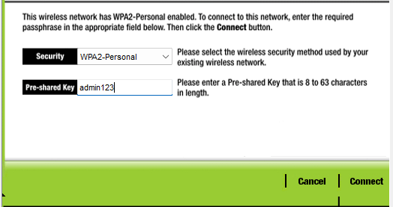

1. **Make each pc wireless connection for Router1**

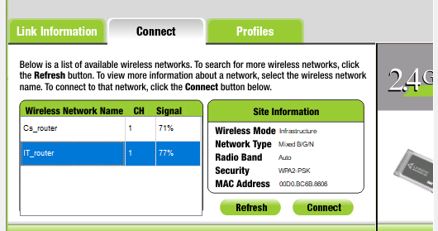

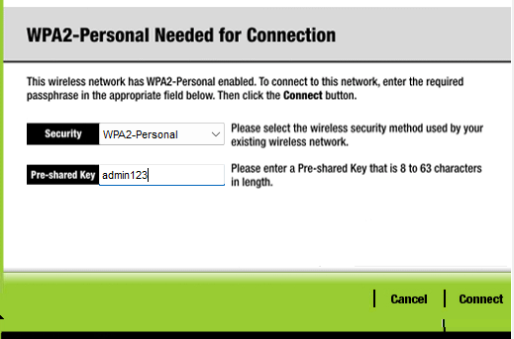

1. **Wireless connection between two Pc with another router**

